Diagnosis of the Auto lending Risk Strategy case

Challenge: “Is the Vehicle Recall – a major risk for the Auto lenders”

Story: An auto recall occurs when a manufacturer determines that a car model (or several models) has a safety-related defect or does not comply with a federal safety standard. When this happens, the automaker will alert owners to the problem and usually offer a free repair. Further a free repair may reduce the actual market value of the vehicle. This may result in negative equity as the owner of the car is paying more to the auto lender than the new actual market value.

Initial Null Hypothesis: “the Vehicle Recall is not a major risk for the Auto lenders”

Dataset: <http://open.canada.ca/data/en/dataset/1ec92326-47ef-4110-b7ca-959fab03f96d>

Sample used for ARIMA: Acura MDX Airbags for Cars, Minivan, Light Vans / Truck and SUV Airbags – a representative sample – having observations from 2013 to 2017 (5 years).

Outputs to be displayed

**#visualize the dataset**

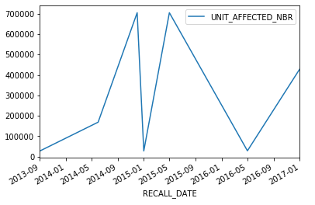

**#checks the auto-correlation plot for the time series. - Result: high negative correlation until 1.5**

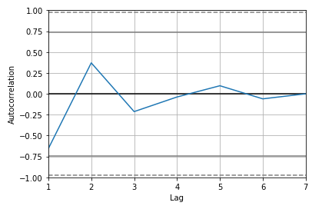

#since there is both negative and positive high correlations at 1, 2 and 3. We use model = ARIMA (dataset, order = (2, 0, 0)), the model works fine with order = (3, 0, 0), but this lead to the insignificant variables in the model.

To study more about **https://people.duke.edu/~rnau/411arim.htm**

**Check the next page for the model outputs and predictions.**

**#Model Output: The model is significant indicating we have to reject the null hypothesis.**

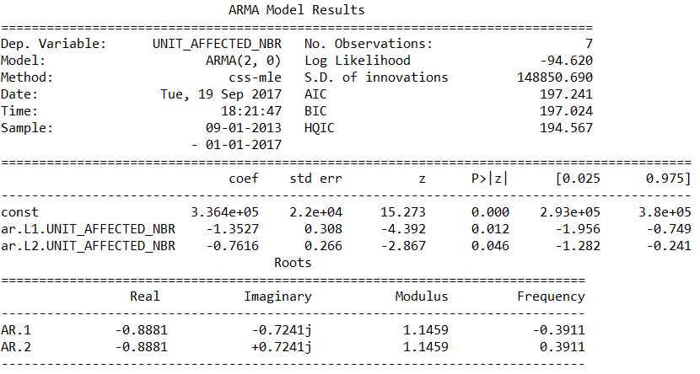

**#Residuals Plot**

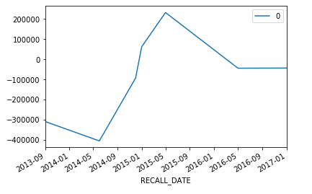

**# Gaussian Density Plot to show the distribution of errors – Slightly skewed on Left**

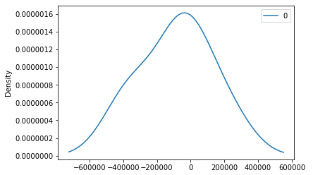

**#further we check the prediction of 2017 using Training and Test Data split (90:10) because we have only one observation in 2017.**

**Predicted=445820, Actuals=428641**